**DBMS Project - Inventory Management System**

|  |  |  |  |  |  |
| --- | --- | --- | --- | --- | --- |
| **Course Code** | **:** | 18CSC303J | **Course Title** | **:** | Database Management Systems |
| **Reg. No.** | **:** | RA1811003010565  RA1811003010568  RA1811003010594 | **Name** | **:** | JAIKANT SINGH RANA  JINESH SINGH NARUKA  ROHAN SINGH RAJPUT |
| **Semester** | **:** | VI Semester | **Year** | **:** | III Year |
| **Name of the faculty in-charge :** | | | Ms.D.Hemavathi | | |

**AIM -** To create an efficient table structure for the DBMS Project on the topic Hospital management system.

**Theory -** Hospital Management System provides the benefits of streamlined operations, enhanced administration & control, superior patient care, strict cost control and improved profitability. HMS is powerful, flexible, and easy to use and is designed and developed to deliver real conceivable benefits to hospitals. More importantly it is backed by reliable and dependable support. The project ‘Hospital Management System’ is based on the database, object oriented and networking techniques. As there are many areas where we keep the records in database for which we are using MY SQL software which is one of the best and the easiest software to keep our information.

**Patient Table:**

|  |  |  |
| --- | --- | --- |
| **Fields** | **Data Type** | **Relationships** |
| Pid | Varchar(5) | Primary Key |
| name | Varchar(20) | Not Null |
| age | NUMBER | Not Null |
| weight | NUMBER | Not Null |
| gender | Varchar(10) | Not null |
| address | Varchar(50) | Not Null |
| phoneno | NUMBER | Not Null |
| disease | Varchar(20) | Not Null |
| doctorid | Varchar(5) | Not Null |

Doctor Table:

|  |  |  |
| --- | --- | --- |
| **Fields** | **Data Type** | **Relationships** |
| doctorid | Varchar(5) | Primary Key |
| doctorname | Varchar(15) | Not Null |
| dept | Varchar(15) | Not Null |

Lab REPORT Table:

|  |  |  |
| --- | --- | --- |
| **Fields** | **Data Type** | **Relationships** |
| labno | Varchar(5) | Primary Key |
| pid | Varchar(5) | Not Null |
| weight | NUMBER | Not Null |
| doctorid | Varchar(5) | Foreign Key |
| date | Date/Time | Not Null |

ADMITTED Patient Table:

|  |  |  |
| --- | --- | --- |
| **Fields** | **Data Type** | **Relationships** |
| pid | Varchar(5) | Primary Key |
| room_no | Varchar(50) | Not Null |
| DOA | Date/Time | Not Null |
| DOD | Date/Time | Not Null |
| advance | NUMBER | Not Null |
| labno | Varchar(5) | Foreign Key |

Bill Table:

|  |  |  |
| --- | --- | --- |
| **Fields** | **Data Type** | **Relationships** |
| pid | Varchar(5) | Foreign Key |
| doctor_charge | NUMBER | Not Null |
| room_charge | NUMBER | Not Null |
| DAYS ADMITTED | NUMBER | Allow Null |
| advance | NUMBER | Allow Null |
| Amount | NUMBER | Allow Null |

**ER diagram**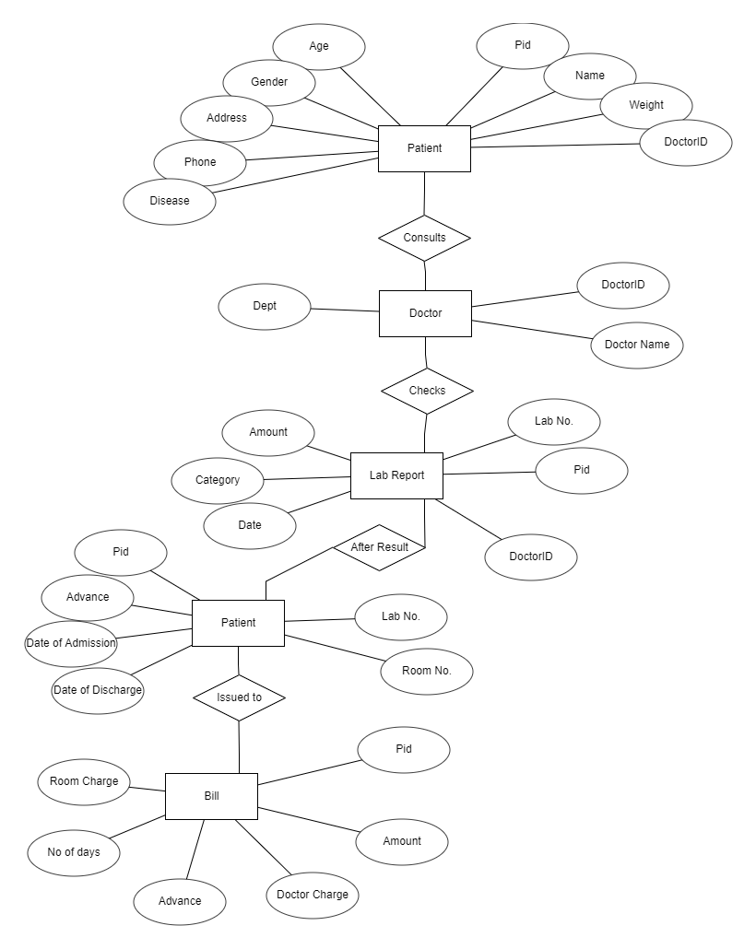

**Table Creation and Value Insertion -**

**PATIENT**

CREATE TABLE PATIENT( PID NUMBER(10) PRIMARY KEY,

NAME VARCHAR(50),

AGE NUMBER(5),

WEIGHT NUMBER(10),

DOCTORID VARCHAR(10),

GENDER CHAR(10),

ADDRESS VARCHAR(50),

PHONE NUMBER(10),

DISEASE VARCHAR (20));

**INPUT**

INSERT INTO PATIENT VALUES( 1, "RAJU" , 34, 86,'D3', 'MALE','23 KAROL BAGH NEW DELHI', 7666551234, 'COVID19');

INSERT INTO PATIENT VALUES(2, "SHEILA" , 26,57,'D2', 'FEMALE','401 MUKHRJEE NAGAR NEW DELHI', 7644551674, 'SURGERY');

INSERT INTO PATIENT VALUES( 3, "MUKESH" , 31, 69,'D1', 'MALE','232 SECTOR-4 DELHI', 9664555534, 'CANCER');

INSERT INTO PATIENT VALUES( 4, "KHUSHI" , 23, 52,'D4', 'FEMALE','23/12 SECTOR 2 NEW DELHI', 8152643597, 'ACCIDENT');

INSERT INTO PATIENT VALUES( 5, "PRATIK" , 27, 77,'D3', 'MALE','44 KESARI BAGH DELHI', 7645236594, 'COVID19');

INSERT INTO PATIENT VALUES( 6, "AKASH" , 19, 64,'D4', 'MALE','212 RAM NAGAR DELHI', 7694576842, 'ACCIDENT');

INSERT INTO PATIENT VALUES( 7, "TARA" , 34, 86,'D2', 'FEMALE','1732 LAXMI NAGAR GURUGRAM', 9564751245, 'SURGERY');

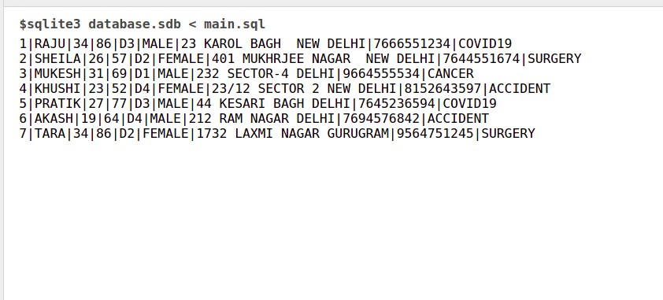

**DOCTOR**

CREATE TABLE DOCTOR( DOCTORID VARCHAR(10) PRIMARY KEY,

DOCTORNAME CHAR(20),

DEPT VARCHAR(15) ,

FOREIGN KEY(DOCTORID) REFERENCES PATIENT(DOCTORID));

**INPUT**

INSERT INTO DOCTOR VALUES('D1', "RINA PATHAK", "ONCOLOGY");

INSERT INTO DOCTOR VALUES('D2', "ABHINAV KUMAR", "SURGEON");

INSERT INTO DOCTOR VALUES('D3', "MEENA RATHORE", "PHYSICIAN");

INSERT INTO DOCTOR VALUES('D4', "RINA PATHAK", "SURGEON");

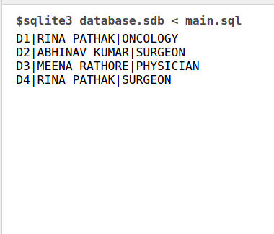

**LAB REPORT**

CREATE TABLE LAB_REPORT(PID NUMBER(10) ,

LAB_NO VARCHAR(5),

DOCTORID VARCHAR(10),

DATE date,

ADMITTED CHAR(10),

FOREIGN KEY(PID) REFERENCES PATIENT(PID));

**INPUT**

INSERT INTO LAB_REPORT VALUES(1,"L2",'D3','2021-05-04', 'YES');

INSERT INTO LAB_REPORT VALUES(2,"L1",'D2','2021-05-06', 'YES');

INSERT INTO LAB_REPORT VALUES(3,"L2",'D1','2021-05-17', 'YES');

INSERT INTO LAB_REPORT VALUES(4,"L3",'D4','2021-05-29', 'YES');

INSERT INTO LAB_REPORT VALUES(5,"L3",'D3','2021-06-09', 'YES');

INSERT INTO LAB_REPORT VALUES(6,"L1",'D4','2021-06-27', 'YES');

INSERT INTO LAB_REPORT VALUES(7,"L2",'D2','2021-07-12', 'YES');

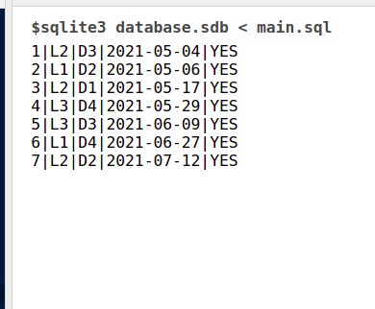

**ADMITTED PATIENT**

CREATE TABLE ADMITTED_PATIENT(PID NUMBER(10),

ROOM_NO VARCHAR(10),

LAB_NO VARCHAR(5),

DOA date,

DOD date,

ADVANCE NUMBER(20),

FOREIGN KEY(PID) REFERENCES PATIENT(PID));

**INPUT**

INSERT INTO ADMITTED_PATIENT VALUES(1, '102','L2','2021-05-04','2021-05-18', 5000);

INSERT INTO ADMITTED_PATIENT VALUES(2, '105','L1','2021-05-06','2021-05-11', 10000);

INSERT INTO ADMITTED_PATIENT VALUES(3, '201','L2','2021-05-17','2021-05-27', 7000);

INSERT INTO ADMITTED_PATIENT VALUES(4, '404','L3','2021-05-29','2021-06-09', 8000);

INSERT INTO ADMITTED_PATIENT VALUES(5, '301','L3','2021-06-09','2021-06-23', 9000);

INSERT INTO ADMITTED_PATIENT VALUES(6, '204','L1','2021-06-27','2021-07-10', 10000);

INSERT INTO ADMITTED_PATIENT VALUES(7, '302','L2','2021-07-12','2021-07-20', 5500);

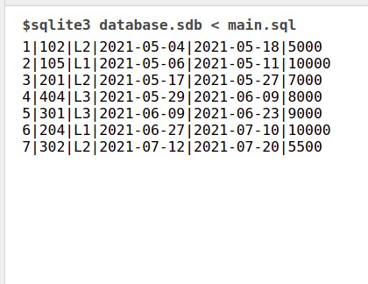

**BILL**

CREATE TABLE BILL(PID NUMBER(10),

DAYS_ADMITTED NUMBER(5),

ROOM_CHARGE NUMBER(20),

DOCTOR_CHARGE NUMBER(20),

ADVANCE NUMBER(20),

AMOUNT NUMBER(20)

,FOREIGN KEY(PID) REFERENCES PATIENT(PID));

**INPUT**

INSERT INTO BILL VALUES(1,14,5600,5000,5000,5600);

INSERT INTO BILL VALUES(2,5,2000,15000,10000,7000);

INSERT INTO BILL VALUES(3,10,4000,72000,7000,69000);

INSERT INTO BILL VALUES(4,10,4000,17000,8000,13000);

INSERT INTO BILL VALUES(5,14,5600,5000,9000,5600);

INSERT INTO BILL VALUES(6,14,5600,5000,10000,600);

INSERT INTO BILL VALUES(7,8,3200,17000,5500,14700);

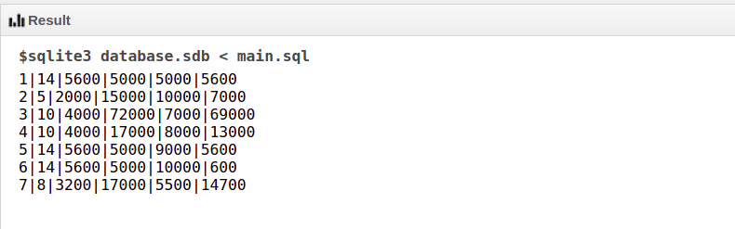

**QUERY**

**GET RECORD OF SPECIFIC PATIENT :**

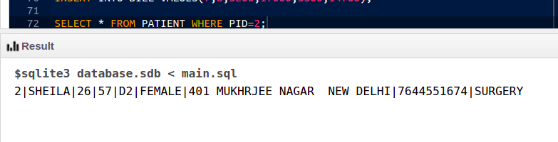

**GET RECORD OF SPECIFIC PATIENTS TREATED BY SAME DOCTOR :**

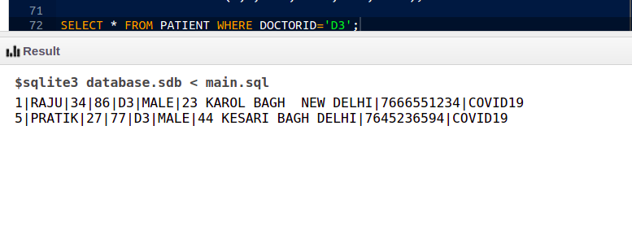

**GET RECORDS OF THE PATIENT TESTED IN A PARTICULAR LAB ON A PARTICULAR DATE :**

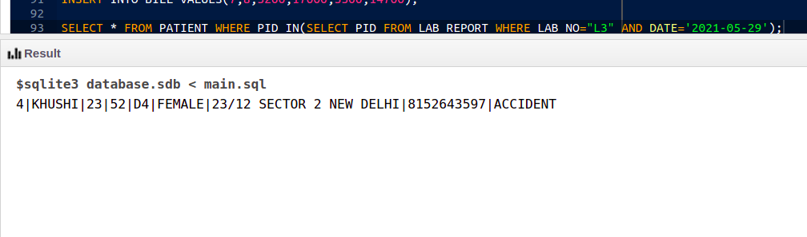

**GET FEES EARNED BY A SPECIFIC DOCTOR :**

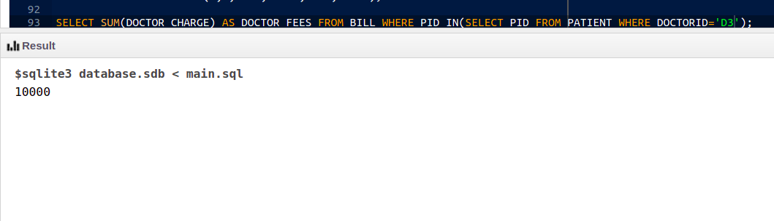

**GET TOTAL NUMBER OF DAYS, ROOM CHARGE SPEND BY ACCIDENT PATIENT IN HOSPITAL :**

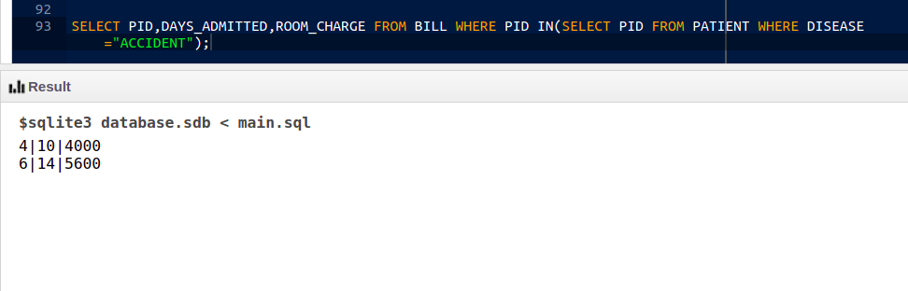

**GET TOTAL AMOUNT SPEND BY PATIENT GROUPED BY DISEASE :**

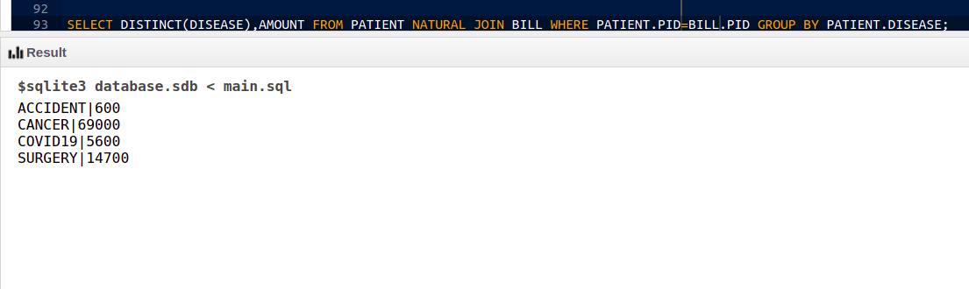

**Get DETAILS OF PATIENTS DISCHARGED AFTER 20TH JUNE 2021:**

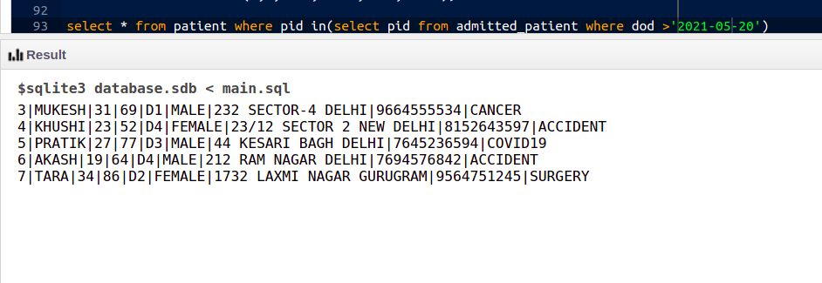

**GET DETAILS OF PATIENT WHO IS ABOVE 25 YEARS OLD AND HAS AMOUNT MORE THAN 10000:**

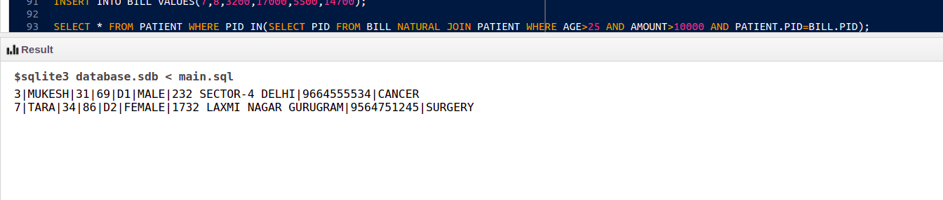

**BEFORE:**

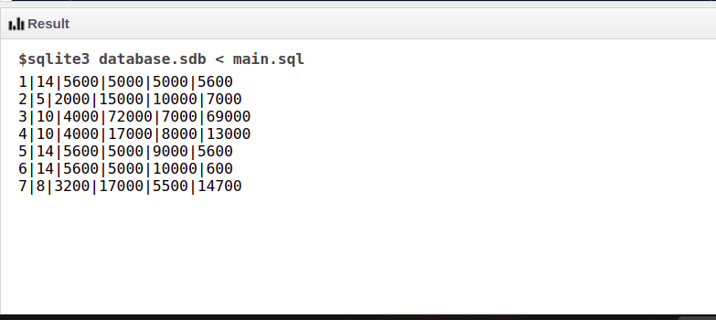

**TRIGGER :**

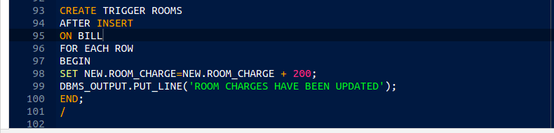**AFTER :**

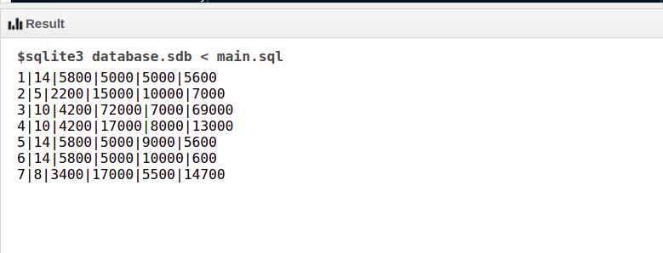

**FUNCTION TO DISPLAY AMOUNT FOR A PATIENT :**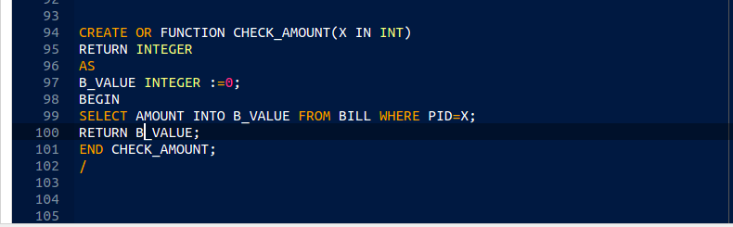

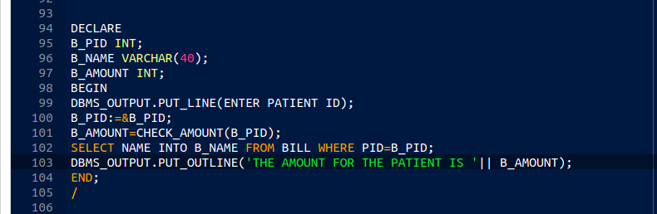

**Result** - An efficient table structure for the DBMS Project on the topic Hospital Management System was successfully created.